DML

**Insert data into the MY_EMPLOYEE table.**

1. Run the script the following command to create the my_employees table and confirm you have it. Then open a separate query tool for your exercise.

CREATE TABLE my_employees (

id INT PRIMARY KEY,

last_name VARCHAR(25),

first_name VARCHAR(25),

userid VARCHAR(25),

salary NUMERIC(9, 2) DEFAULT 1000

);

1. Create an INSERT statement to add **the first row** of data to the MY_EMPLOYEE table from the following sample data. **Do not list the columns in the INSERT clause**. *Do not enter all rows yet.*

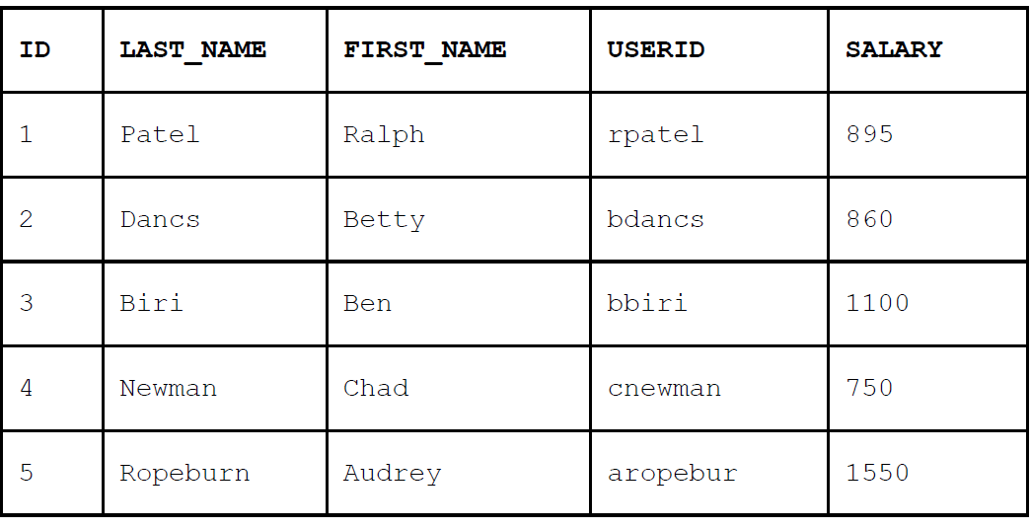

1. Populate the MY_EMPLOYEE table with the second row of the sample data from the precedinglist. This time, list the columns explicitly in the INSERT clause.
2. Confirm your addition to the table.

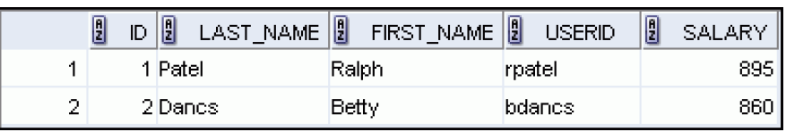

1. Populate the table with the next two rows of the sample data listed in step 2 in a way of your choosing.
2. Confirm your additions to the table.

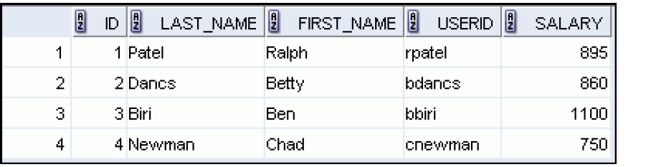

1. Change the last name of employee 3 to Drexler.
2. Change the salary to $1,000 for all all employees who have a salary less than $900.
3. Verify your changes to the table.

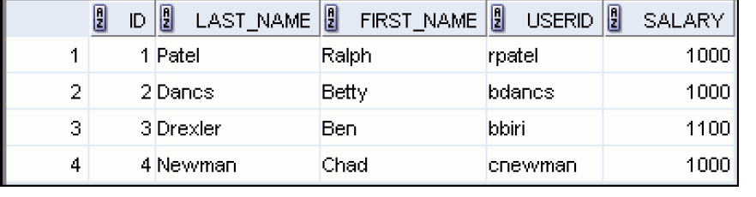

1. Delete Betty Dancs from the MY_EMPLOYEE table.
2. Confirm your changes to the table.

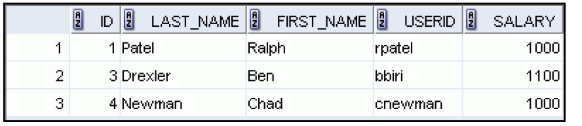

--**If you have time**

**\*Note in the following steps you will need to open a transaction, any error in the syntax will result in blocking you out until you exit the transaction, if you encounter such problem- use the rollback statement and go back to step 12**

1. Begin a transaction
2. Populate the table with the last row of the sample data listed in step 2 and confirm your changes

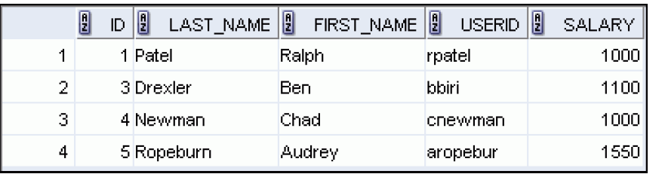

1. Update all those whose last name ends with ‘n’ to get the default salary
2. Observe your table, than use a command to undo the changes you made since step 12, and observe it again.

**--if you have more time**

**Note in the following steps you will need to open a transaction, any error in the syntax will result in blocking you out until you exit the transaction, if you encounter such problem- use the rollback statement and go back to step 16**

1. With one INSERT command populate you table with employees from departments 50, use their email as “userid” and give them 15% raise for the new salary.
2. Delete all rows with id between 100 and 300.
3. Begin a transaction and repeat step 16. Look at your table.
4. Create a savepoint
5. In my_employees table- Update the salaries of all employees who make more then 4000 to earn 4001.
6. Check your table to see if it worked.
7. Rollback the changes to the save point then commit.